Project Specification

Portfolio task 2

Unit code: COS40005

Unit Name: Computing Technology Project A

Submission date: Feb 3rd, 2024

|  |  |  |
| --- | --- | --- |
| Student Name | Student Id | Statement of contribution to the report |
| Nguyen Thi Thanh Minh | 104169617 | Led the structuring and drafting of the project specification, ensuring clarity and completeness. |
| Duong Viet Minh Hoang | 104513696 | Assisted in defining system requirements and refining functional and non-functional requirements. |
| Nguyen Sy Thanh Trung | 104224529 | Contributed to the system architecture and database schema documentation. |
| Doan Quang Lam | 104225991 | Reviewed and refined technical descriptions, ensuring alignment with Agile methodologies. |

# **Acknowledgment of Country**

All of the team members are currently based in Da Nang, Vietnam, making this section inapplicable.

# **Problem Statement**

The increasing need for personalized healthcare systems has led to the development of AI-assisted tools capable of providing tailored health insights based on individual needs. This project aims to develop a system that leverages AI to provide health recommendations based on users' medical histories, current health status, and lifestyle patterns. The system will also enable timely communication between patients and healthcare professionals.

Aim: To develop an AI-powered Personalized Health Assistant that offers real-time health recommendations and medical assistance.

Objectives:

* Develop a chatbot-enabled system for user interaction and health inquiries.
* Implement AI models for personalized recommendations and medical imaging analysis.
* Create a secure and scalable backend for health data storage and management.
* Enable scheduling and communication with healthcare professionals.

# **Scope**

### In-Scope Features:

* AI-powered personalized health recommendations based on health status and medical records.
* Secure and efficient backend system for data processing.
* User-friendly frontend interface for seamless interaction.
* Real-time health monitoring and insights.
* Appointment scheduling system for users and doctors.

### Out-of-Scope Features:

* Direct medical diagnosis or treatment recommendations.
* Integration with medical-grade devices requiring regulatory approval.

# **Stakeholders**

* Team Members: Nguyen Thi Thanh Minh, Duong Viet Minh Hoang, Nguyen Sy Thanh Trung, Doan Quang Lam.
* End Users: Individuals seeking personalized health insights.
* Potential Investors: Interested in health-tech innovations.
* Product Holder: Dr. Ly Quynh Tran.
* Healthcare Providers: Medical professionals collaborating for patient insights.

# **High-level Description**

SmartHealth is a **new and complete AI-driven health assistant system** designed to assist users in managing their health efficiently. It consists of three main components:

* AI Module: Analyzes user data, including medical history and real-time health metrics.
* Backend System: Secure and scalable data processing and storage solution.
* User Interface: Intuitive platform for user interaction, including chatbot assistance.

A simple system architecture includes:

* Frontend: Vue.js 3
* Backend: Python (FastAPI) with MySQL database
* AI Model: Machine Learning for health recommendations
* Cloud Services: AWS for hosting and security.

## Product Features

* AI-based personalized health insights.
* Secure user authentication and data encryption.
* Interactive and user-friendly interface.
* Health tracking and real-time recommendations.
* Appointment scheduling system for patients and doctors.

## System requirements

### Software Requirements:

* Frontend: Vue.js 3 to develop a responsive, interactive user interface that supports a dashboard for user profiles, health tracking, and chatbot interactions (*Vue.Js*, n.d.).
* Backend: FastAPI-based Python server with MySQL database. Process incoming requests, implement business logic (such as authentication, appointment scheduling, and health data processing), and interact with both the AI modules and the database (*FastAPI*, n.d.).
* AI/ML:
  + Machine Learning Model: For generating personalized health recommendations (diet, exercise, and lifestyle changes).
  + Large Language Model (LLM): For powering the AI chatbot that provides real-time health advice based on user input.
  + Computer Vision Model: For medical imaging analysis, enabling the system to process and diagnose images (e.g., X-rays) using models such as YOLOv8 and ResNet (Widayani et al., 2024).

### Hardware Requirements:

* AWS EC2 instance with at least 8GB of memory to host the backend services and support the computational demands of the AI modules.
* Secure backend server to ensure reliable deployment and secure operations of the infrastructure.

## System Architecture

To complement the software and hardware requirements, the following system architecture outlines how the SmartHealth Personalized Health Assistant is organized and how its various components interact. This architecture not only clarifies data flow and processing responsibilities but also emphasizes scalability and security.

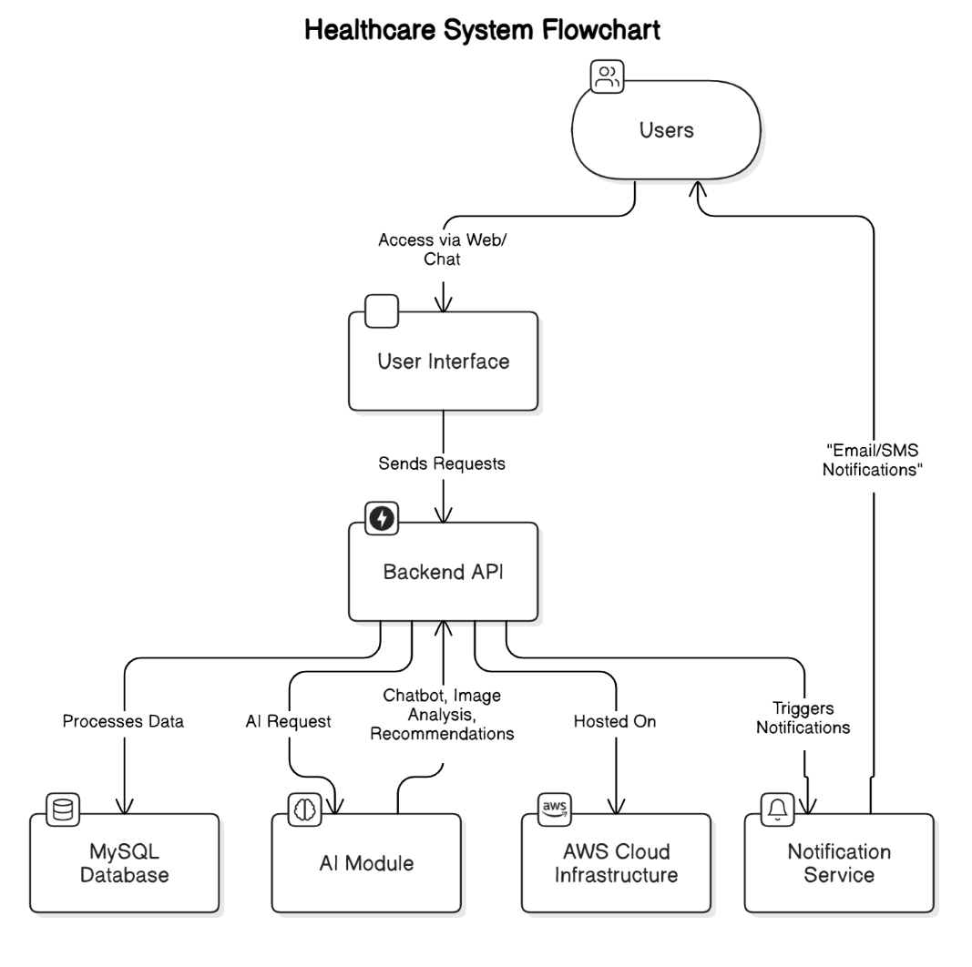

*Figure 1 – System architecture for SmartHealth with components and their interaction*

### Components and Their Roles:

* Users: Represent the external actors accessing the system.
* User Interface: Built with Vue.js 3, providing the entry point for interactions.
* Backend API: Manages business logic, security, and coordination between services.
* MySQL Database: Stores all persistent data.
* AI Module: Encompasses the LLM for chatbot functionalities, the health recommendation engine, and computer vision for image analysis.
* Notification Service: Manages the delivery of timely alerts and reminders.
* AWS Cloud Infrastructure: Provides the scalable, secure hosting environment for the entire system.

## acceptance criteria

* The application should provide accurate AI-driven recommendations based on user input.
* Users should be able to securely log in and access their health data.
* The system should support real-time health tracking and updates.
* The user interface should be intuitive and accessible on multiple devices.

## documentation

The following documents will be delivered with the system:

* User Manual
* API Documentation
* Technical Architecture Document
* Deployment Guide

# **Requirement Specification**

This section details the identified requirements for the SmartHealth Personalized Health Assistant system. Requirements are categorized into functional, non-functional, and interface specifications.

## functional requirements

The system must provide core functionalities for personalized health assistance, AI-driven recommendations, medical data processing, and user management.

### User Management

|  |  |  |  |  |
| --- | --- | --- | --- | --- |
| **ID** | **Feature** | **Requirement Statement** | **Rationale** | **Notes** |
| FR-01 | User Registration & Authentication | Users must be able to create accounts, log in, and securely manage profiles. | Ensures secure access to health data. | Authentication via OAuth2. |
| FR-02 | Profile Management | Users can update personal information, medical history, and health metrics. | Enables personalized recommendations. | Data encryption required. |

### AI-Driven Health Assistance

|  |  |  |  |  |
| --- | --- | --- | --- | --- |
| **ID** | **Feature** | **Requirement Statement** | **Rationale** | **Notes** |
| FR-03 | AI Chatbot | Users receive AI-driven health advice based on symptoms and history. | Enhances accessibility and real-time guidance. | Based on GPT model. |
| FR-04 | Health Recommendations | AI suggests diet, exercise, and lifestyle changes. | Provides actionable insights. | Uses machine learning models. |

### Medical Image Processing

|  |  |  |  |  |
| --- | --- | --- | --- | --- |
| **ID** | **Feature** | **Requirement Statement** | **Rationale** | **Notes** |
| FR-05 | Image Upload & Analysis | Users can upload X-ray images for AI-based diagnosis. | Supports early disease detection. | Uses YOLOv8 and ResNet models. |

### Appointment Management

|  |  |  |  |  |
| --- | --- | --- | --- | --- |
| **ID** | **Feature** | **Requirement Statement** | **Rationale** | **Notes** |
| FR-06 | Appointment Scheduling | Users can book consultations with doctors. | Streamlines access to medical professionals. | Integrated with calendar APIs. |
| FR-07 | Appointment Notifications | Users receive automated appointment reminders via email/SMS. | Reduces missed appointments. | Requires third-party notification API. |

## non-functional requirements

These requirements define quality aspects that the system must meet.

|  |  |  |  |
| --- | --- | --- | --- |
| **ID** | **Requirement Statement** | **Rationale** | **Notes** |
| NFR-01 | The system must support at least 10,000 concurrent users. | Ensures scalability for wide adoption. | Performance testing required. |
| NFR-02 | The system must have 99.9% uptime. | Ensures high availability. | Cloud infrastructure on AWS. |
| NFR-03 | User data must be encrypted using AES-256. | Ensures privacy and security compliance. | Applies to both storage and transmission. |
| NFR-04 | The system must respond to user queries within 2 seconds. | Improves user experience. | Includes AI processing optimization. |

## interface requirements

The system must communicate with external entities during execution.

### System in Context

The SmartHealth system interacts with:

* Users (patients and healthcare professionals) via a web interface and chatbot.
* External APIs for AI processing, medical image analysis, and cloud storage.
* Notification Services (SMS/Email for appointment reminders).

### User Interface

* Web-based frontend built with Vue.js 3.
* Chatbot-powered interface for health inquiries.
* Dashboard for user profile management and health tracking.

### Hardware Interface

* AWS EC2 instance with at least 8GB RAM for backend services.
* Cloud-based GPU instances for AI model processing.

### Software Interface

The system integrates with:

* MySQL database for storing user and health data.
* LLM API for chatbot functionalities.
* YOLOv8 and ResNet for medical image analysis.

### Communication Interface

* HTTPS for secure API communication.
* OAuth2 for authentication with third-party services.
* WebSockets for real-time updates (e.g., appointment reminders).

# **References**

*FastAPI*. (n.d.). Retrieved February 3, 2025, from https://fastapi.tiangolo.com/

*Vue.js*. (n.d.). Retrieved February 3, 2025, from https://vuejs.org/

Widayani, A., Putra, A. M., Maghriebi, A. R., Adi, D. Z. C., & Ridho, Moh. H. F. (2024). Review of Application YOLOv8 in Medical Imaging. *Indonesian Applied Physics Letters*, *5*(1), 23–33. https://doi.org/10.20473/iapl.v5i1.57001

**Client Sign off**

|  |  |  |  |
| --- | --- | --- | --- |
| **Name** | **Position** | **Signature** | **Date** |
|  |  |  |  |
| **Organisation** | | | |
|  | | | |

*[Client to sign off on the Project Plan to signify they agree with the plan]*